Extend the project by integrating with Amazon Rekognition

In this module, you will learn how to integrate the project with Amazon Rekognition and view the output over CloudWatch.

### Step 1- Create a DynamoDB table:

1. Go to console.aws.amazon.com and search for DynamoDB

2. Click on Create Table.

3. Next, we need to create the DynamoDB table that will store our output:

Name the table: recognize-emotions

Primary key: s3key

Use default settings

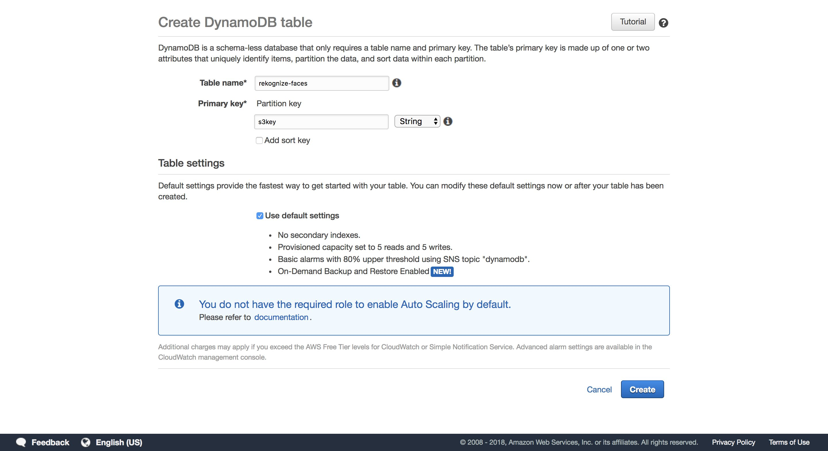

Click on Create. This will create a table in your DynamoDB.

**Step 2- Create a lambda function that runs in the cloud**

The inference lambda function that you deployed earlier will upload the cropped faces to your S3. On S3 upload, this new lambda function gets triggered and runs the Rekognize Emotions API by integrating with Amazon Rekognition.

To create the lambda function, follow the steps below:

1. Go to lambda console by visiting console.aws.amazon.com/lambda

2. Click on ‘Create function’ and choose Author from scratch

3. Name the function- recognize-emotion. Choose Python 2.7 as the run time

4. For the role, select ‘choose an existing role’ aand choose the “rekognizeEmotion” role we created earlier

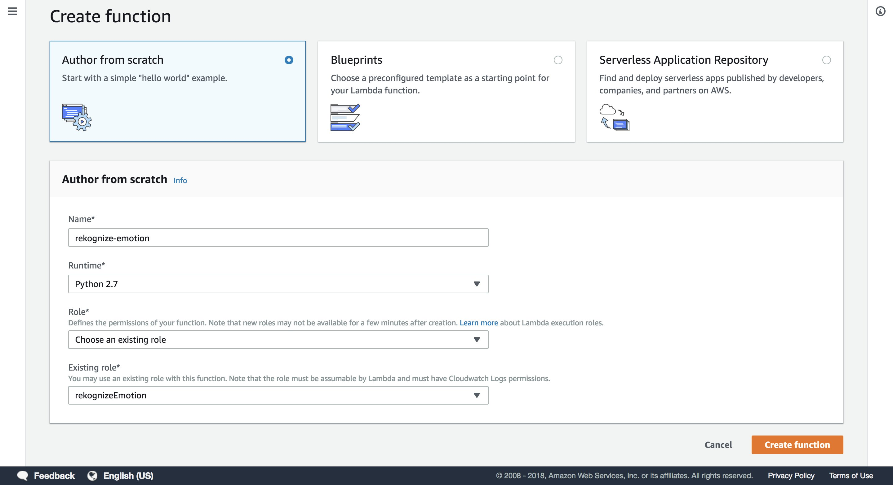

5. Replace the default script with the script in **recognize-emotions.py (you can find it in the github repo),**

The script does the following functions:

* Is triggered upon S3
* Writes metrics to CloudWatch
* Logs metrics to the DynamoDB table created earlier

Once the script is inserted, it should look like the below:

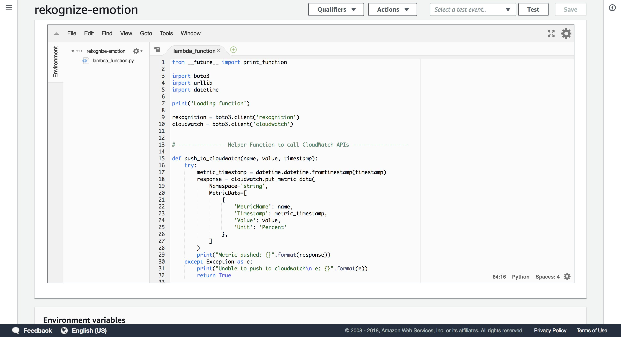

6. Next, we need to add the event that triggers this lambda function. This will be an “S3:ObjectCreated” event that happens every time a face is uploaded to the face S3 bucket

Add the “S3” trigger:

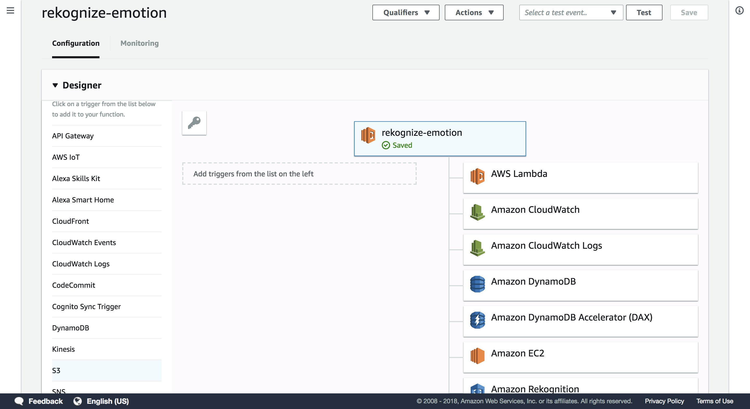

With the following configuration:

Bucket name- <your bucket name> (we created this s3 bucket in our earlier steps)

Event type- Object Created

Prefix- faces/

Filter- .jpg

Enable trigger- ON (keep the checkbox on)

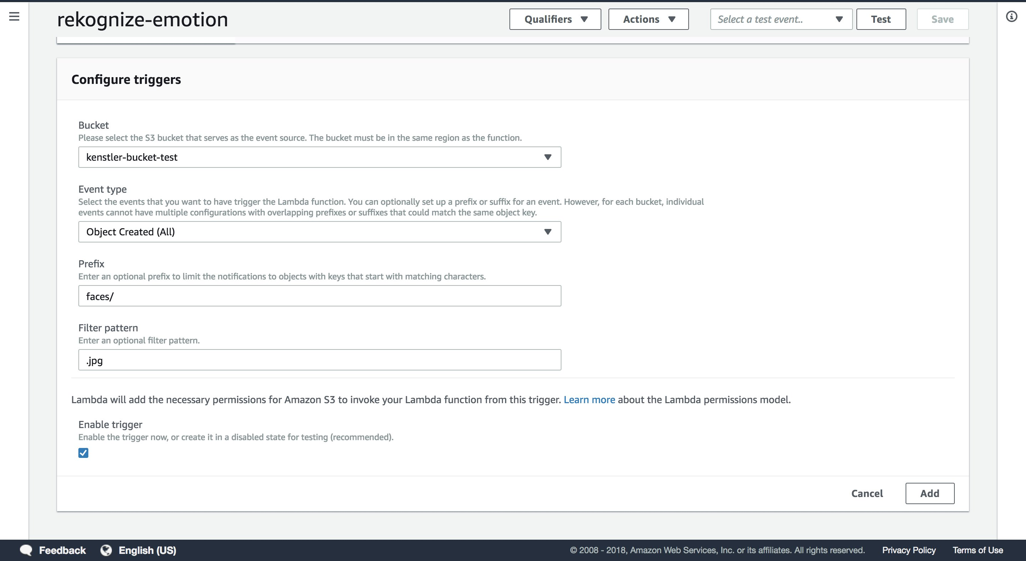

7. Save the lambda function.

**8. Publish the lambda function.**